CS 6643 - Computer Vision & Image Analysis

New York University

Tandon School of Engineering

Project 2: Face Recognition

Ayan Agrawal

Net ID: aka398

**a) Programming Language used and Instruction on how to compile the program:**

Programming Language: Python 2.7

Instruction to compile:

a) Go to command prompt of the desktop

b) Copy and paste the below code in the editor of python and save the file name as file_name.py

c) Go to the path where the file_name.py file is located

d) Write the below commands

*python file_name.py*

See the below screenshot for example

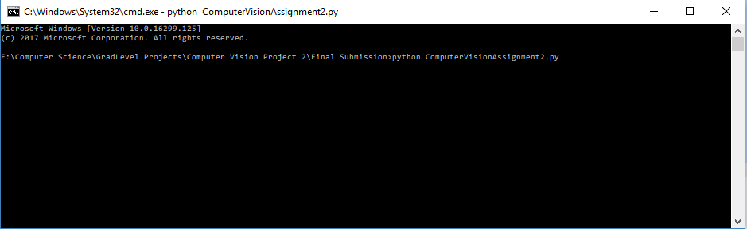

e) Later, test image to be provided when prompted after the training on images is done.

*(See the below screenshot highlighted in yellow)*

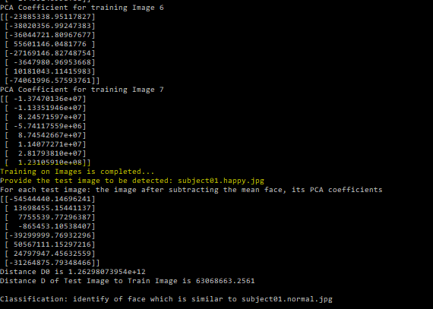

Please note: Below libraries are required for the code to be compiled

sys

math

PIL 🡪 Image

numpy

matplotlib

Source code of the program with inline comments

**import** sys  
**import** math  
*#importing Image library to read and display the image.***from** PIL **import** Image  
*#Library to show the images***from** matplotlib **import** pyplot **as** plt  
**import** matplotlib.image **as** mpimg  
*#Library for matrix calculations***import** numpy **as** np  
*#Library to calculate eigen values and eigen vectors***from** numpy **import** linalg **as** LA  
  
*#==================================Implementing EigenFaces Training Functions===================================================#  
#For each training image, the rows are stacked together to form a column vector Ri of dimension width*heght  
#here all the images are stacked in the list imagesN2vector***def convertToN2vector**(*width*, *height*)**:** imagesN2vector **=** []  
 **for** images **in** range(len(Imageobjects))**:** k **=** 0  
 individualImages **=** np.zeros((*width***\****height*,1),dtype **=** np.int16)  
 **for** i **in** range(*height*)**:  
 for** j **in** range(*width*)**:** *#storing the pixel value in the form of increasing rows with single column* individualImages[k,0] **=** Imageobjects[images].getpixel((j,i))  
 k **=** k **+** 1  
 *#appending single image to stack all the images* imagesN2vector.append(individualImages)  
 **return** imagesN2vector  
  
  
*#The mean face m(meanFace) is computed by taking the average of the M training face images  
#providing the input as obtained in the above method***def averageFaceVector**(*imagesN2vector*)**:** meanFace **=** np.zeros((width**\***height,1),dtype **=** np.int16)  
 M **=** len(*imagesN2vector*)  
 **for** i **in** range(len(*imagesN2vector*[0]))**:** sum **=** 0  
 *#taking the sum of all pixel in one row and dividing by the number of images* **for** images **in** range(len(*imagesN2vector*))**:** sum **=** sum **+** *imagesN2vector*[images][i][0]  
 sum **=** sum**/**M  
 meanFace[i][0] **=** sum  
 **return** meanFace  
  
*#subtracting the mean face m from each training face  
#providing the input as obtained in the above method to subtract***def subtractMeanFace**(*imagesN2vector*, *meanFace*)**:** subtractmeanface **=** []  
 **for** images **in** range(len(Imageobjects))**:** *#using the subtract function of the numpy library* individualImages **=** np.subtract(*imagesN2vector*[images],*meanFace*)  
 *#appending the individual subtracted image stacked in one list* subtractmeanface.append(individualImages)  
 **return** subtractmeanface  
  
*#All training faces into a single matrix A of dimension [width*height, no_of_test_images]  
#providing the input as obtained in the above method***def matrixA**(*R*)**:** A **=** np.zeros((width**\***height,len(*R*)),dtype **=** np.int16)  
 **for** i **in** range(width**\***height)**:  
 for** j **in** range(len(*R*))**:** A[i,j] **=** *R*[j][i][0]  
 **return** A  
  
*#since calculation of eigen values and eigen vectors from co-variance matrix will require large computational effort as matrix will be large  
#Implementing the alternate method to calculate the eigenvalues  
#AT is the transpose of matrix A obtained above  
#taking the dot product of AT and A to get the matrix L  
# calculating the eigenvalue and eigen vector  
# w is the eigenvalue, V is the eigenvector***def alternateToCovariance**(*A*)**:** AT **=** np.transpose(*A*)  
 L **=** np.dot(AT, *A*)  
 w, V **=** LA.eig(L)  
 **return** V  
  
*#Eigen vectors of C can be found by U = AV  
# U is the eigenspace, face spave or eigenfaces***def covariance**(*A*, *V*)**:** U **=** np.dot(*A*, *V*)  
 **return** U  
  
*#printing all the eigen faces based on the dataset of the images provided.  
# For 8 trained image we will get 8 eigenFaces***def printEigenFaces**(*U*)**:  
 for** i **in** range (len(*U*[0]))**:** plt.title('Eigen face'**+** str(i))  
 plt.imshow((*U*[**:**,i].reshape(231,195)),cmap**=**'gray')  
 plt.show()  
  
*#Each training face can then be projected on the face space  
#UT is the transpose of U as obtained above  
#projectedfacespace = (UT)(Ri)***def projectedFaceSpace**(*U*, *R*)**:** UT **=** np.transpose(*U*)  
 rows, column **=** UT.shape  
 projectedfacespace **=** []  
 **for** images **in** range(len(Imageobjects))**:** projectedfacespace.append(np.dot(UT, *R*[images]))   
 **return** projectedfacespace  
  
*#printing all the PCA coefficients from the projected face space obtained in above method  
#8 training image will have 8 set of PCA coeffients***def printPCACoefficients**(*projectedfacespace*)**:  
 for** i **in** range(len(*projectedfacespace*))**:  
 print** "PCA Coefficient for training Image", i  
 **print** *projectedfacespace*[i]  
  
  
*#==================================Implementing EigenFaces Recognition Functions===================================================#  
#reading the test image of which the face needs to be recognized  
#the function will take single test image at a time***def getTestImage**(*width*, *height*)**:** Testimage **=** np.zeros((*width***\****height*,1),dtype **=** np.int16)  
 k **=** 0  
 **for** i **in** range(*height*)**:  
 for** j **in** range(*width*)**:** Testimage[k,0] **=** test_image_object.getpixel((j,i))  
 k **=** k **+** 1  
 **return** Testimage  
  
*#subtracting the mean face m from each test face  
#Mean face m was obtained in the above training methods  
#providing the input as obtained in the above method to subtract***def subtractTestFace**(*testimage*, *meanFace*)**:** subtracttestface **=** np.subtract(*testimage*,*meanFace*)  
 **return** subtracttestface  
  
*#computing its projection onto the face space  
#UT is the transpose of U as obtained above in the training method  
#projectionface = (UT)(I)  
#I is the subtracted image as obtained above after subtracting***def projectiononFace**(*U*, *I*)**:** projectionface **=** np.dot(np.transpose(*U*), *I*)  
 **return** projectionface  
  
*#Reconstruct input face image from the eigenfaces  
#reconstructedimage = (U)(projectionface)  
#where U is the eigenface and the projectionFace of the test image is obtained above***def reconstruct**(*U*, *projectionface*)**:** reconstructedimage **=** np.dot(*U*, *projectionface*)  
 **return** reconstructedimage  
  
*#Computing the distance between the input face image and the reconstruction of the image  
#Subtracting the value pixel by pixel and then passing the complete vector to get the euclidean distance***def findEuclideanDistance**(*reconstructedimage*, *I*)**:** subtractedform **=** np.subtract(*reconstructedimage*, *I*)  
 subtractedform **=** LA.norm(subtractedform)  
 **return** subtractedform  
  
*#Compute distance between input face image and training images in the face space  
#projectionface is the projected test face  
#projectedfacespace[i] is the individual traing images  
#Test image is subtracted from all the training images then the image with the minimum distance is taken with the image in the dataset***def computeDistance**(*projectionface*, *projectedfacespace*)**:** Di **=** []  
 **for** i **in** range(len(*projectedfacespace*))**:** di **=** LA.norm(np.subtract(*projectionface*, *projectedfacespace*[i]))  
 Di.append(di)  
 **return** Di  
  
**def displayFinalResult**(*testpath*,*imagePath*)**:** plt.title('Input Test Image')  
 plt.imshow(mpimg.imread(*testpath*),cmap**=**'gray')  
 plt.figure()  
 plt.imshow(mpimg.imread(*imagePath*),cmap**=**'gray')  
 plt.title('Resulting image')  
 plt.show()  
  
*#==================================================================================================================================  
#EigenFaces Training  
#Training Dataset  
#TrainingImages list contains the set images as training dataset  
#change the path in the 'imagePath' variable where all the images are stored  
#change to the path of images stored on the machine*storedimagepath **=** "Dataset**\\**"  
TrainingImages **=** ['subject01.normal.jpg', 'subject02.normal.jpg', 'subject03.normal.jpg', 'subject07.normal.jpg', 'subject10.normal.jpg', 'subject11.normal.jpg', 'subject14.normal.jpg', 'subject15.normal.jpg']  
Imageobjects **=** []  
**for** i **in** range(len(TrainingImages))**:** imagePath **=** storedimagepath **+** TrainingImages[i]  
 image_object **=** Image.open(imagePath)  
 Imageobjects.append(image_object)  
*#All the images are of same size  
#Calculating the width and height*width, height **=** Imageobjects[0].size  
  
imagesN2vector **=** convertToN2vector(width, height)  
  
meanFace **=** averageFaceVector(imagesN2vector)  
plt.title("Mean Face m")  
plt.imshow(meanFace.reshape(231,195), cmap **=** "gray")  
plt.show()  
  
R **=** subtractMeanFace(imagesN2vector, meanFace)  
  
A **=** matrixA(R)  
  
V **=** alternateToCovariance(A)  
  
U **=** covariance(A, V)  
  
printEigenFaces(U)  
  
projectedfacespace **=** projectedFaceSpace(U, R)  
  
printPCACoefficients(projectedfacespace)  
  
*#=========================================================================================================================================  
#Testing  
#EigenFaces Recognition*print "Training on Images is completed..."

testImage = raw_input("Provide the test image to be detected: ")

testimagePath = "Dataset\\" + testImage  
test_image_object **=** Image.open(testimagePath)  
width, height **=** test_image_object.size  
  
testimage **=** getTestImage(width, height)  
  
I **=** subtractTestFace(testimage, meanFace)  
plt.title("The image after subtracting from the mean face")  
plt.imshow(I.reshape(231,195), cmap **=** "gray")  
plt.show()  
  
projectionface **=** projectiononFace(U, I)  
**print** "For each test image: the image after subtracting the mean face, its PCA coefficients"  
**print** projectionface  
  
reconstructedimage **=** reconstruct(U, projectionface)  
plt.title("The reconstructed face Image")  
plt.imshow(reconstructedimage.reshape(231,195), cmap **=** "gray")  
plt.show()  
  
subtractedform **=** findEuclideanDistance(reconstructedimage, I)  
**print** "Distance D0 is",subtractedform  
*#Choosing the threshold  
#T0 is used to identify whether the image is face or non-face*T0 **=** 7000000000000  
*#T1 is used to identify whether the face is present in the dataset or not*T1 **=** 89000000  
**if** (subtractedform **>** T0)**:  
 print** ""  
 **print** "Classification: non-face"  
  
**else:** Di **=** computeDistance(projectionface, projectedfacespace)

**print** "Distance D of Test Image to Train Image is",min(Di)  
 **if** (min(Di) **>** T1)**:  
 print** ""  
 **print** "Classification: unknown face"  
 **else:  
 print** ""  
 **print** "Classification: identify of face which is similar to", TrainingImages[Di.index(min(Di))]  
   
 displayFinalResult(testimagePath,storedimagepath **+** TrainingImages[Di.index(min(Di))])

1) Manually chosen Threshold values **T0 = 7000000000000 T1 = 89000000**

The mean Face *m* is

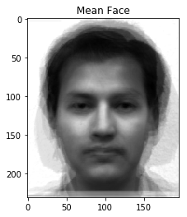

**The M Eigenfaces are**

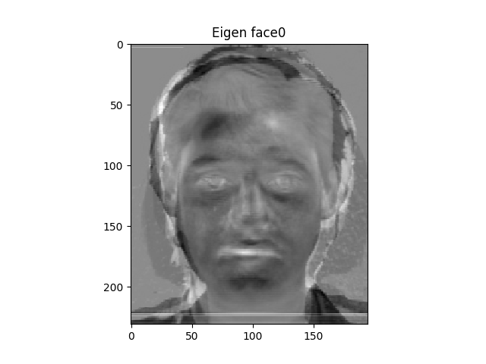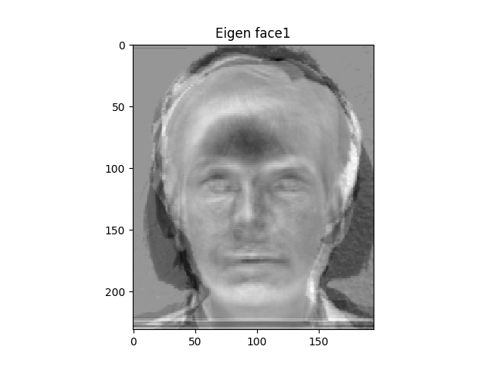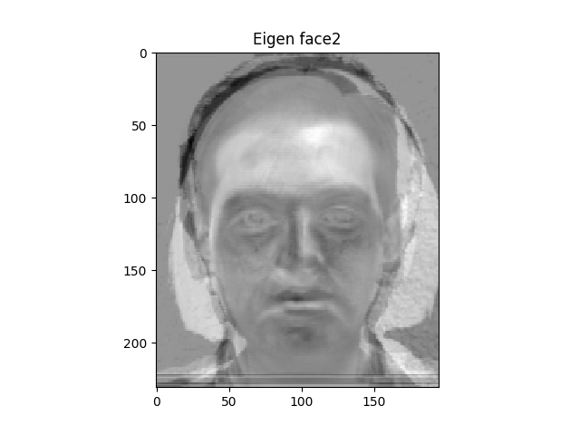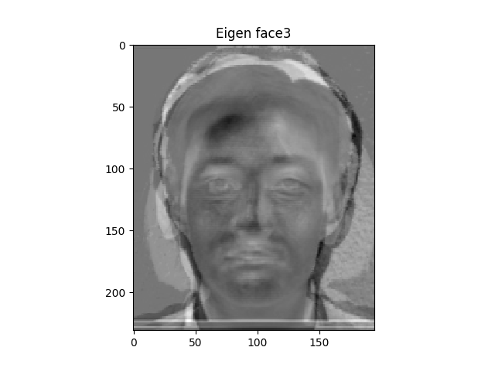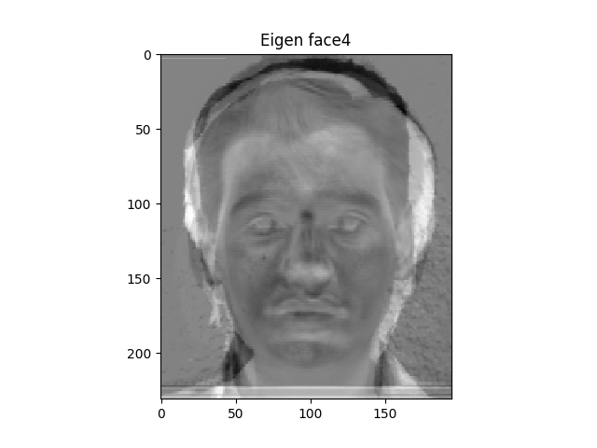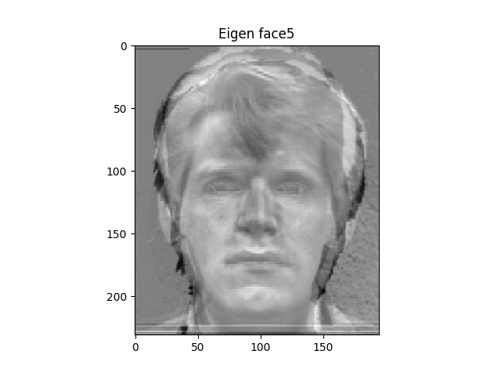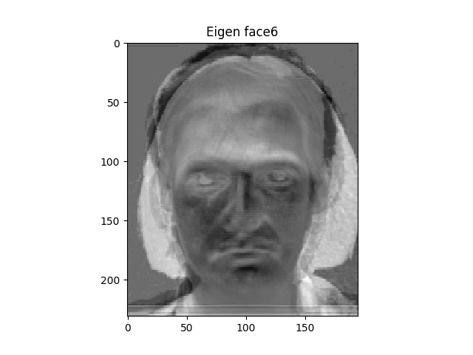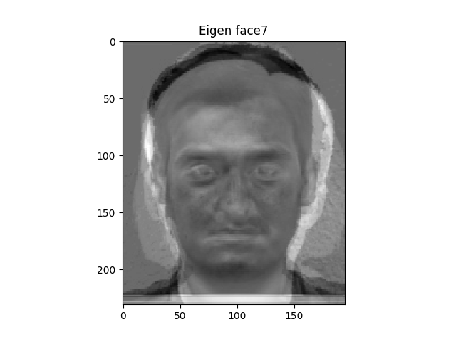

**(2) The PCA coefficients (𝛺𝑖) for each training image.**

PCA Coefficient for training Image 'subject01.normal.jpg'

[[-80205224.60550584], [ 10921231.32780848], [ -7900044.86273242], [ 6733589.57055455],

[-73825931.56067842], [ 78334122.09522335], [ 11902241.54677157], [-60917507.72030157]]

PCA Coefficient for training Image 'subject02.normal.jpg'

[[ 27892934.57546353], [ 44730062.0064938 ], [ 69311634.75480063], [-34802096.75608037],

[ 60037790.27052878], [-34354328.33880106], [ 52984127.12661389], [ 19034103.74077592]]

PCA Coefficient for training Image 'subject03.normal.jpg'

[[-28668031.43676752], [-57753655.62062956], [ -5769809.31555467], [-31032457.53040214],

[ -6704369.90149155], [-11911976.36457956], [ 45679017.82804587], [ 65466025.71603002]]

PCA Coefficient for training Image 'subject07.normal.jpg'

[[ 5.79712078e+07], [ -2.73065746e+06], [ 1.92375614e+07], [ 2.19613691e+07],

[ 7.65241976e+07], [ -4.51439070e+07], [ 7.99699093e+07], [ 1.20183374e+08]]

PCA Coefficient for training Image 'subject10.normal.jpg'

[[ 40076541.46590143], [-50802807.97120582], [ 34765863.02261727], [ 34687717.42100515]

[-55313829.4070871 ], [-15704513.25544917], [-17965697.71993631], [-45287637.82963333]]

PCA Coefficient for training Image 'subject11.normal.jpg'

[[ 1.62112834e+07], [ 1.03868223e+08], [ -1.54883456e+08], [ -4.69933026e+07]

[ -6.21221660e+07], [ 2.41960251e+07], [ -2.08372249e+08], [ -1.45914099e+08]]

PCA Coefficient for training Image 'subject14.normal.jpg'

[[-23885338.95117828], [-38020356.99247386], [-36044721.80967672], [ 55601146.04817761]

[-27169146.82748754], [ -3647980.96953667], [ 10181043.11415982], [-74061996.57593761]]

PCA Coefficient for training Image 'subject15.normal.jpg'

[[ -1.37470136e+07], [ -1.13351946e+07], [ 8.24571597e+07], [ -5.74117559e+06]

[ 8.74542667e+07], [ 1.14077271e+07], [ 2.81793810e+07], [ 1.23105910e+08]]

**(3) For each test image:**

**1 ) For Image: subject01.centerlight.jpg**  
The image after subtracting the mean face (𝐼)

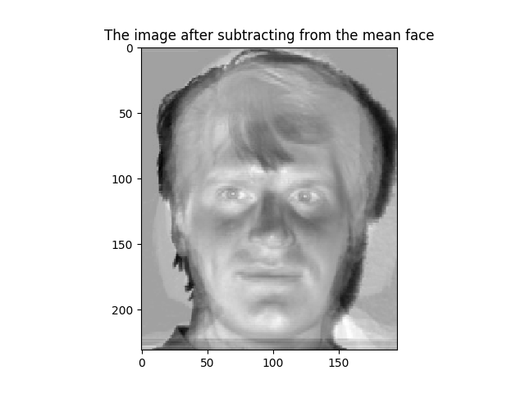

PCA coefficients

[[-14872799.77606913]

[ 22294172.21058068]

[ -1576774.69698971]

[ -8284186.99806547]

[-18069392.98878718]

[ 19700950.31492519]

[-11467257.15441374]

[-34471886.86632913]]

The reconstructed face image (𝐼𝑅)

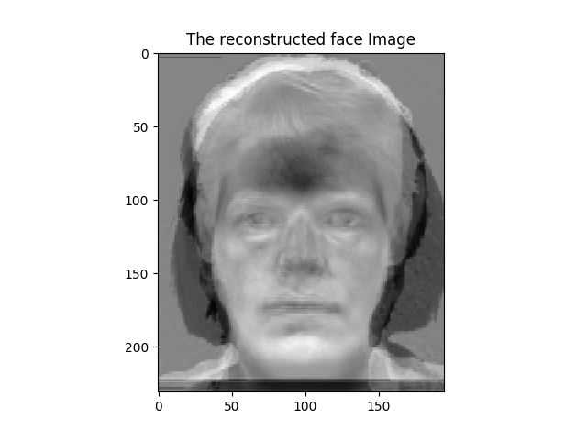

**Distance D0** is 917157501536.0

**Distance D** of Test Image to Train Image is 107946501.821

**Classification:** unknown face

**2) For Image: subject01.happy.jpg**  
The image after subtracting the mean face (𝐼)

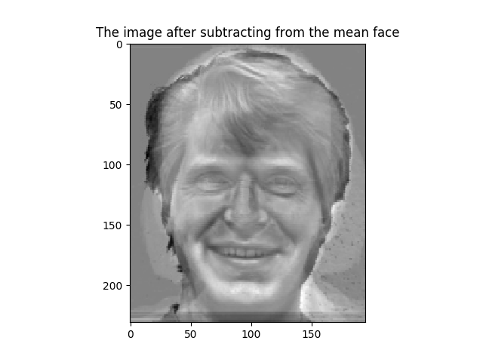

PCA coefficients

[[-54544440.14696241]

[ 13698455.15441137]

[ 7755539.77296387]

[ -865453.10538407]

[-39299999.76932296]

[ 50567111.15297216]

[ 24797947.45632559]

[-31264875.79348466]]

The reconstructed face image (𝐼𝑅)

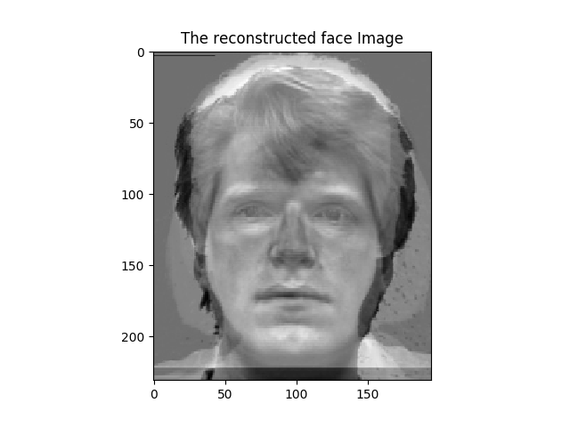

**Distance D0** is 1.26298073954e+12

**Distance D** of Test Image to Train Image is 63068663.2561

**Classification:** identify of face which is similar to subject01.normal.jpg

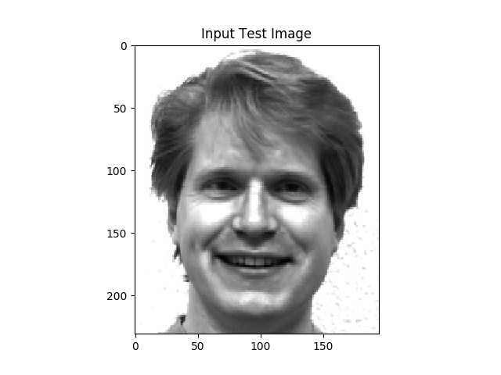 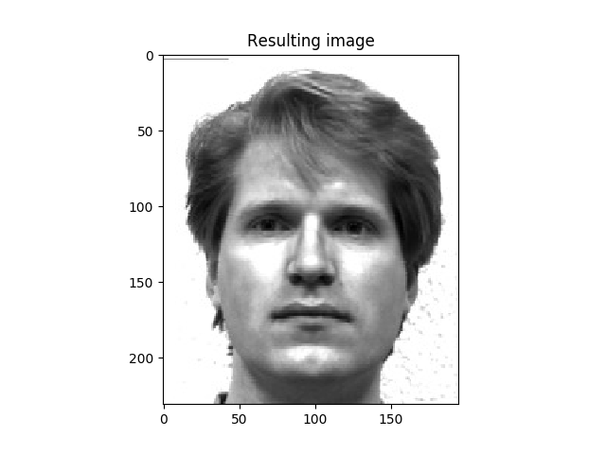

**3) For Image: subject01.normal.jpg**  
The image after subtracting the mean face (𝐼)

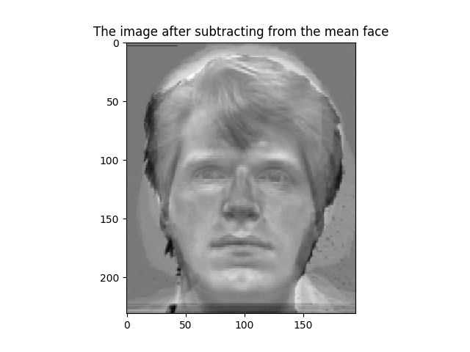

PCA coefficients

[[-80205224.60550581]

[ 10921231.32780861]

[ -7900044.86273236]

[ 6733589.57055458]

[-73825931.56067851]

[ 78334122.09522331]

[ 11902241.54677152]

[-60917507.72030156]]

The reconstructed face image (𝐼𝑅)

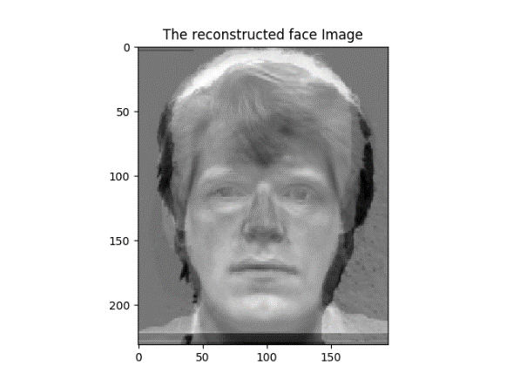

**Distance D0** is 2.24581189888e+12

**Distance D** of Test Image to Train Image is 0.0

**Classification:** Identify of face which is similar to subject01.normal.jpg

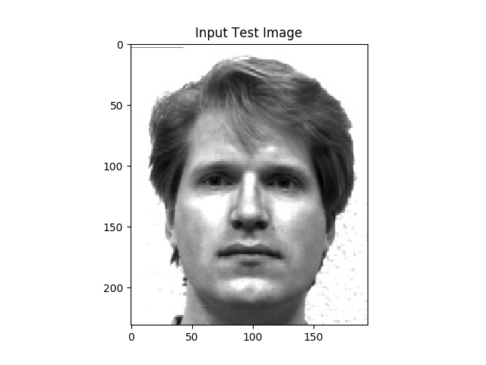 

**4) For Image: subject02.normal.jpg**  
The image after subtracting the mean face (𝐼)

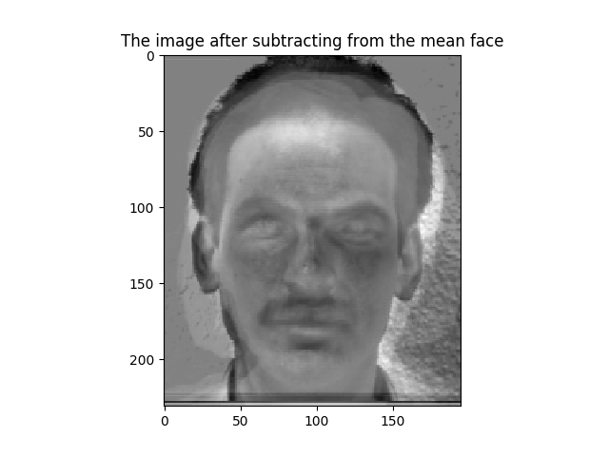

PCA coefficients

[[ 27892934.57546354]

[ 44730062.00649374]

[ 69311634.75480068]

[-34802096.75608035]

[ 60037790.2705288 ]

[-34354328.33880103]

[ 52984127.12661389]

[ 19034103.74077592]]

The reconstructed face image (𝐼𝑅)

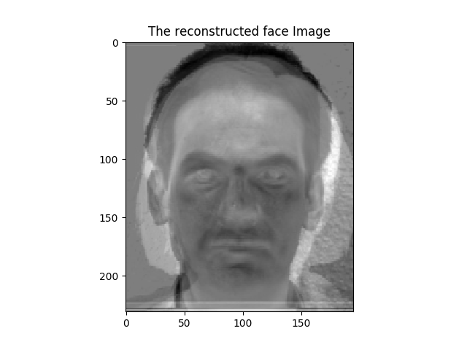

**Distance D0** is 2.04860054474e+12

**Distance D** of Test Image to Train Image is 0.0

**Classification:** Identify of face which is similar to subject02.normal.jpg

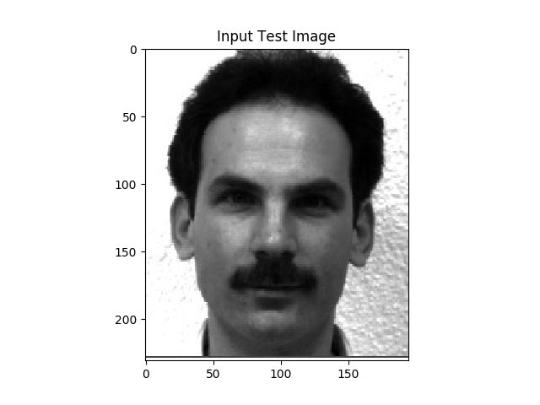 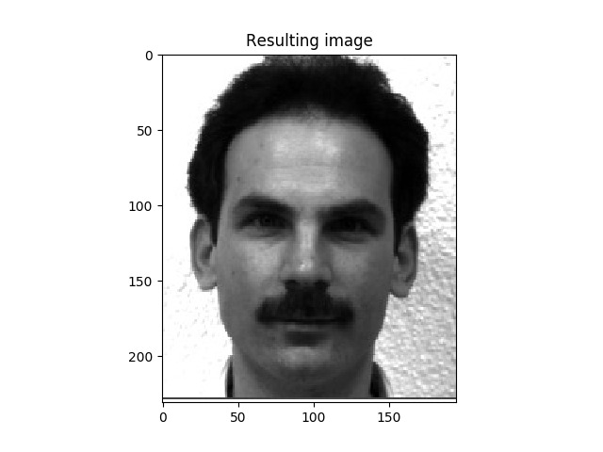

**5) For Image: subject03.normal.jpg**  
The image after subtracting the mean face (𝐼)

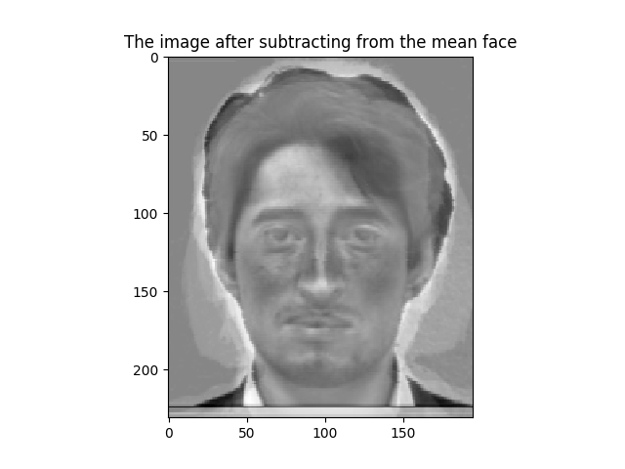

PCA coefficients

[[-28668031.43676755]

[-57753655.62062956]

[ -5769809.31555461]

[-31032457.53040218]

[ -6704369.90149159]

[-11911976.36457955]

[ 45679017.82804589]

[ 65466025.71603002]]

The reconstructed face image (𝐼𝑅)

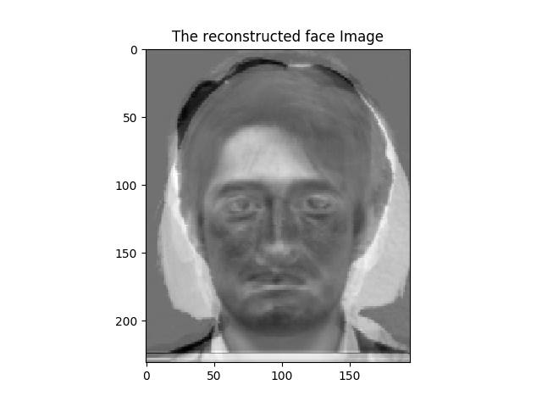

**Distance D0** is 1.62824684849e+12

**Distance D** of Test Image to Train Image is 0.0

**Classification:** Identify of face which is similar to subject03.normal.jpg

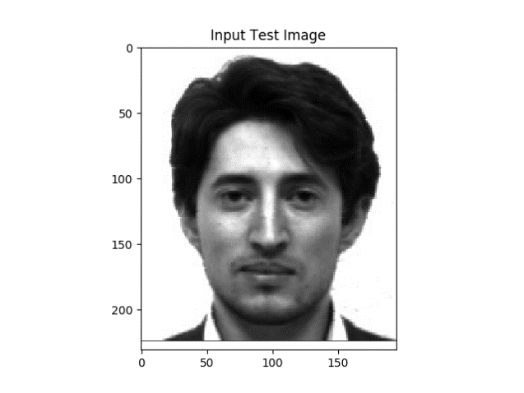 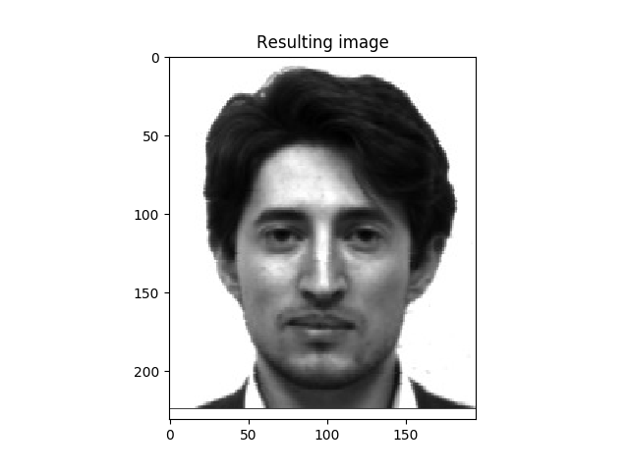

**6) For Image: subject07.centerlight**  
The image after subtracting the mean face (𝐼)

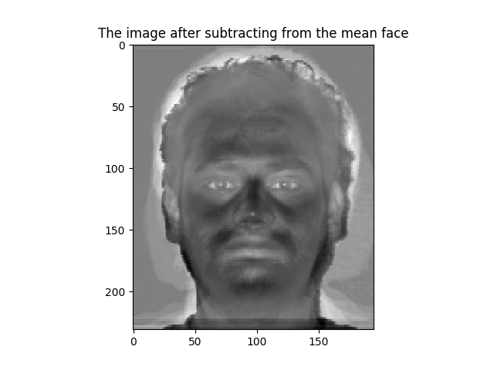

PCA coefficients

[[ 32786080.66342004]

[-20850065.70159742]

[ -7764624.32620306]

[ 38308921.84201576]

[ 3025138.90665058]

[-32061098.96800448]

[ 15473938.21380893]

[-19330412.34346486]]

The reconstructed face image (𝐼𝑅)

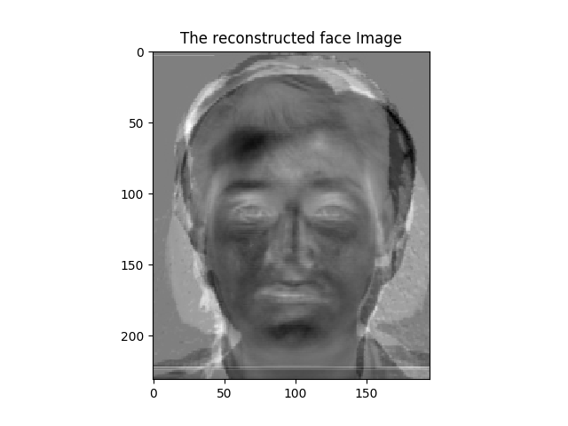

**Distance D0** is 783149411393.0

**Distance D** of Test Image to Train Image is 90748184.5007

**Classification:** unknown face

**7) For Image: subject07.happy**  
The image after subtracting the mean face (𝐼)

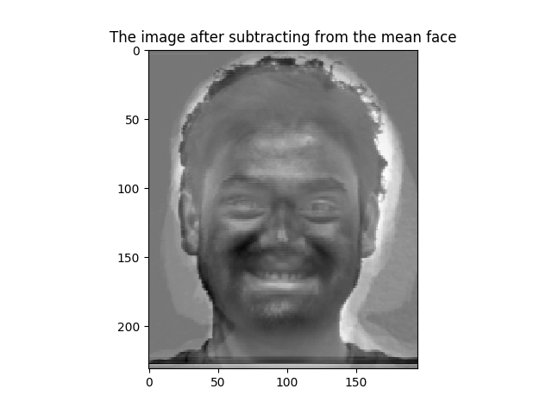

PCA coefficients

[[ 22694887.72016218]

[-21292171.28866842]

[ 37807675.25791071]

[ 16129797.15767356]

[ 41269293.45986101]

[-26048131.31434928]

[ 53249561.49343546]

[ 60167647.89946216]]

The reconstructed face image (𝐼𝑅)

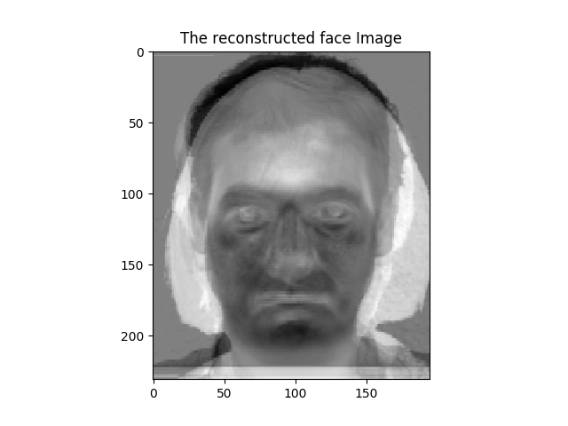

**Distance D0** is 2.12385368524e+12

**Distance D** of Test Image to Train Image is 88832574.2068

**Classification:** Identify of face which is similar to subject07.normal.jpg

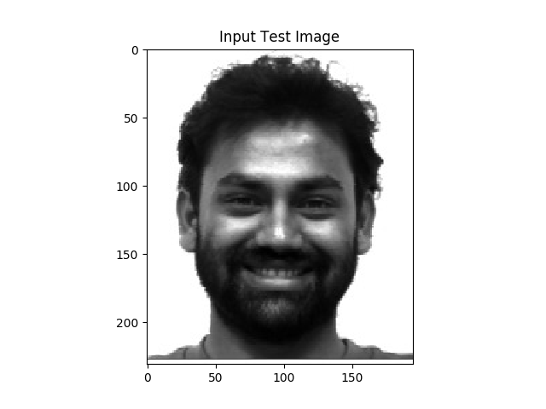 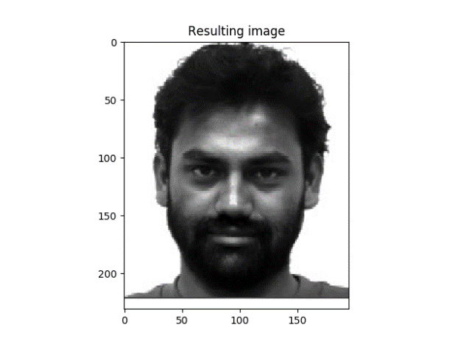

**8) For Image: subject07.normal**  
The image after subtracting the mean face (𝐼)

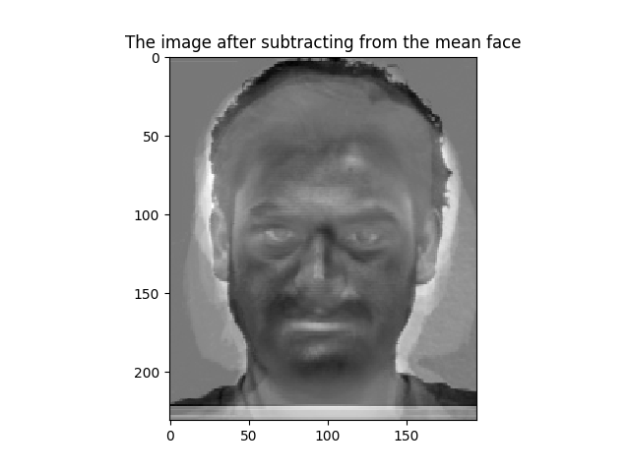

PCA coefficients

[[ 5.79712078e+07]

[ -2.73065746e+06]

[ 1.92375614e+07]

[ 2.19613691e+07]

[ 7.65241976e+07]

[ -4.51439070e+07]

[ 7.99699093e+07]

[ 1.20183374e+08]]

The reconstructed face image (𝐼𝑅)

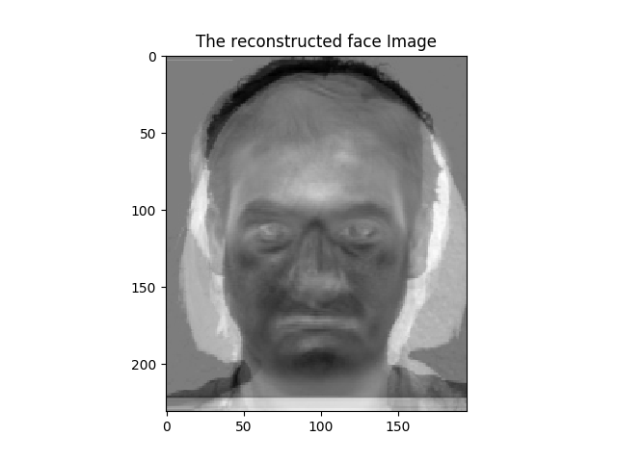

**Distance D0** is 3.38521595036e+12

**Distance D** of Test Image to Train Image is 0.0

**Classification:** Identify of face which is similar to subject07.normal.jpg

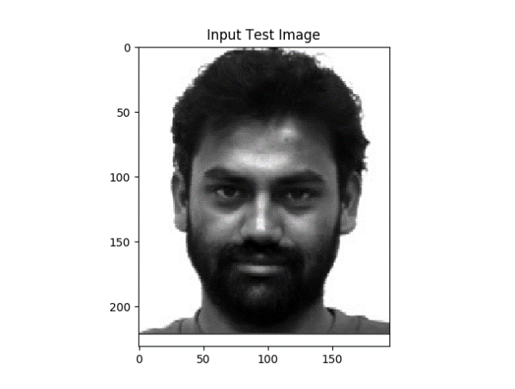 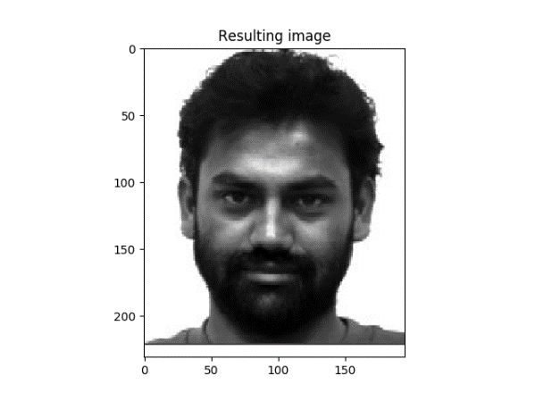

**9) For Image: subject10.normal**  
The image after subtracting the mean face (𝐼)

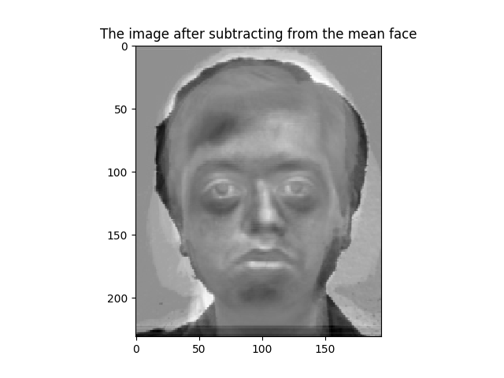

PCA coefficients

[[ 40076541.46590145]

[-50802807.97120582]

[ 34765863.02261723]

[ 34687717.42100519]

[-55313829.40708707]

[-15704513.25544923]

[-17965697.7199363 ]

[-45287637.82963336]]

The reconstructed face image (𝐼𝑅)

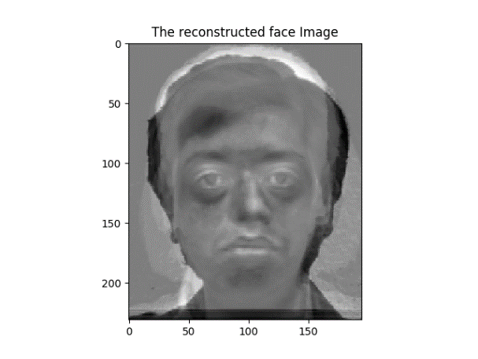

**Distance D0** is 1.35493722207e+12

**Distance D** of Test Image to Train Image is 0.0

**Classification:** Identify of face which is similar to subject10.normal.jpg

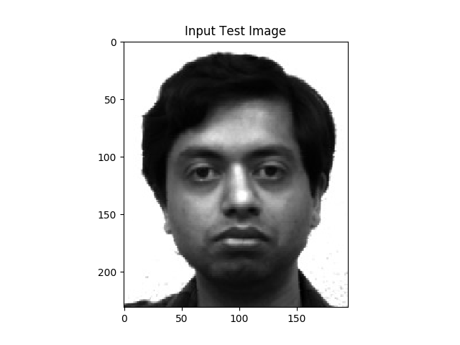 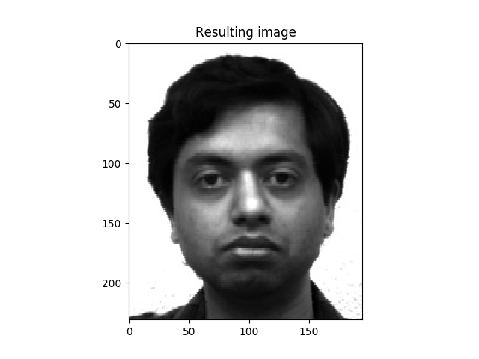

**10) For Image: subject11.centerlight**  
The image after subtracting the mean face (𝐼)

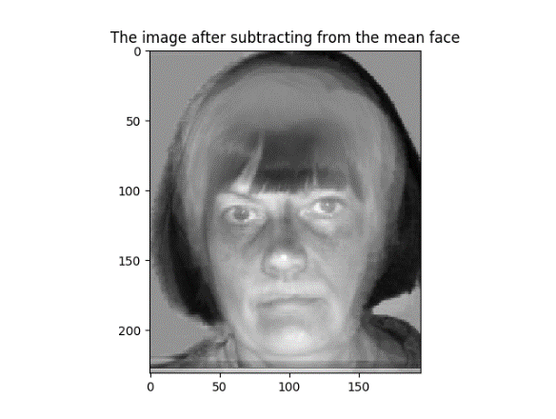

PCA coefficients

[[ 3.42153564e+07]

[ 1.04208376e+08]

[ -9.88799316e+07]

[ -5.21542850e+07]

[ -7.16501257e+05]

[ -4.08491357e+06]

[ -1.38612238e+08]

[ -8.08906554e+07]]

The reconstructed face image (𝐼𝑅)

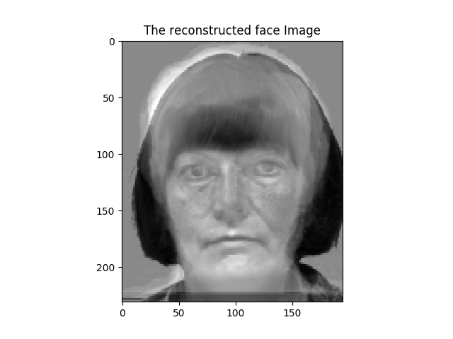

**Distance D0** is 4.12146771073e+12

**Distance D** of Test Image to Train Image is 130966665.208

**Classification:** unknown face

**11) For Image: subject11.happy**  
The image after subtracting the mean face (𝐼)

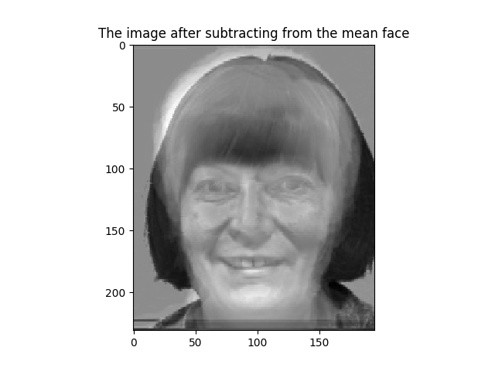

PCA coefficients

[[ 1.74586565e+07]

[ 1.07322365e+08]

[ -1.47788862e+08]

[ -4.81995240e+07]

[ -4.86603885e+07]

[ 1.89942320e+07]

[ -1.96510220e+08]

[ -1.38150826e+08]]

The reconstructed face image (𝐼𝑅)

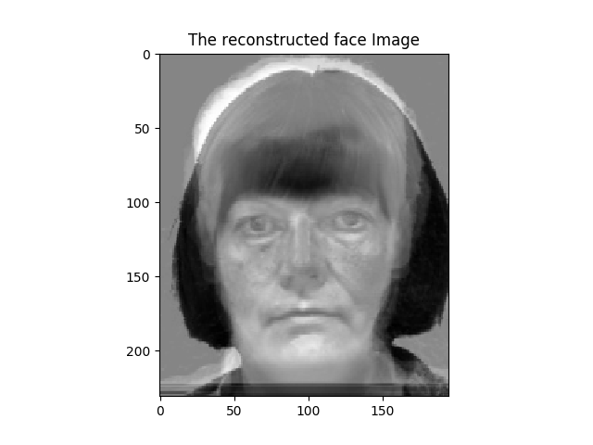

**Distance D0** is 6.06667954242e+12

**Distance D** of Test Image to Train Image is 21783698.2848

**Classification:** Identify of face which is similar to subject11.normal.jpg

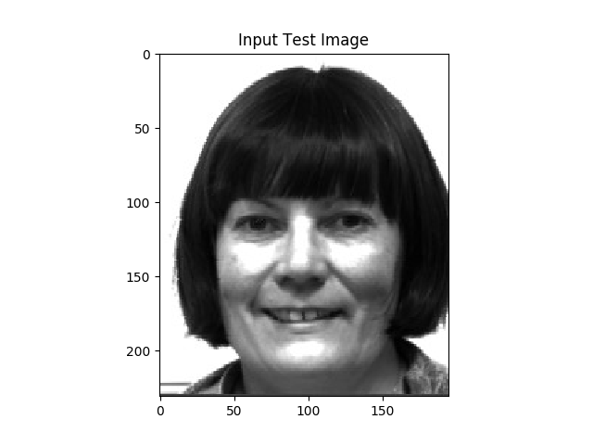 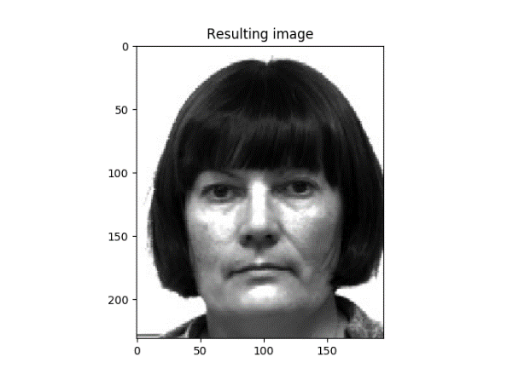

**12) For Image: subject11.normal**  
The image after subtracting the mean face (𝐼)

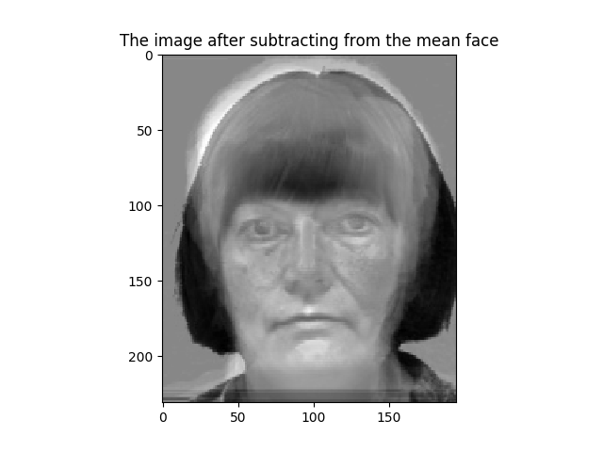

PCA coefficients

[[ 1.62112834e+07]

[ 1.03868223e+08]

[ -1.54883456e+08]

[ -4.69933026e+07]

[ -6.21221660e+07]

[ 2.41960251e+07]

[ -2.08372249e+08]

[ -1.45914099e+08]]

The reconstructed face image (𝐼𝑅)

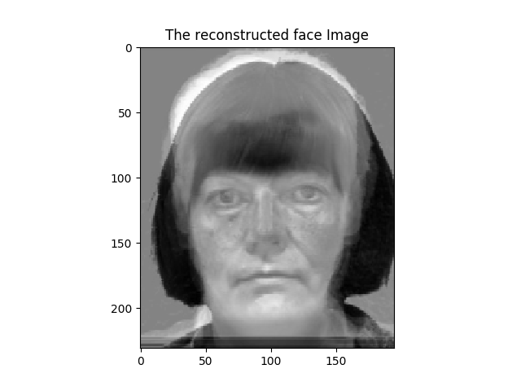

**Distance D0** is 6.41360821122e+12

**Distance D** of Test Image to Train Image is 0.0

**Classification:** Identify of face which is similar to subject11.normal.jpg

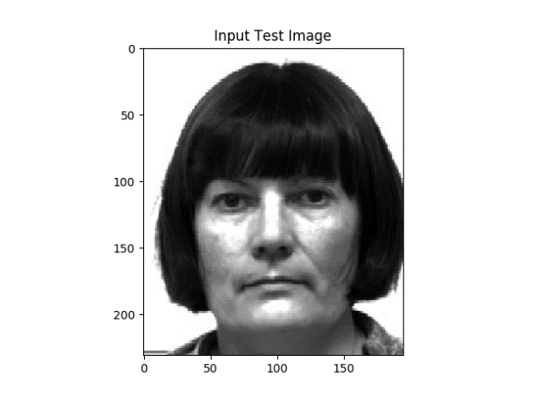 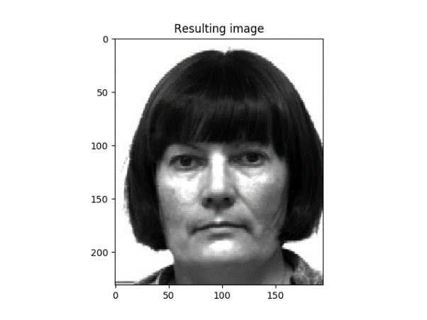

**13) For Image: subject12.normal**  
The image after subtracting the mean face (𝐼)

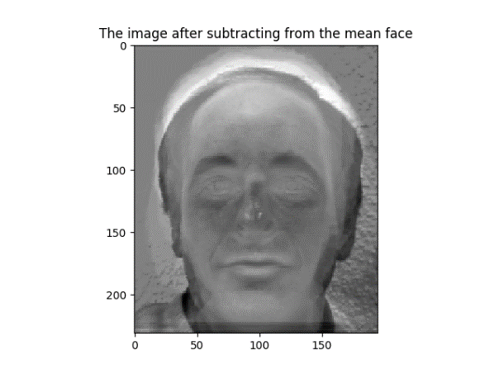

PCA coefficients

[[ -6357288.10402619]

[ 20931027.62905409]

[-17170228.37407878]

[ 16170931.67471084]

[-33129640.19396954]

[ 15978828.15499067]

[-26776279.85087397]

[-76728642.89871714]]

The reconstructed face image (𝐼𝑅)

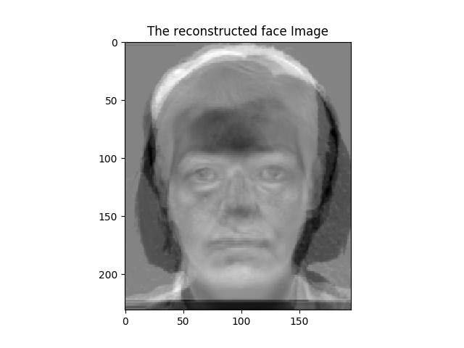

**Distance D0** is 1.7772096763e+12

**Distance D** of Test Image to Train Image is 86528495.0997

**Classification:** identify of face which is similar to subject14.normal.jpg

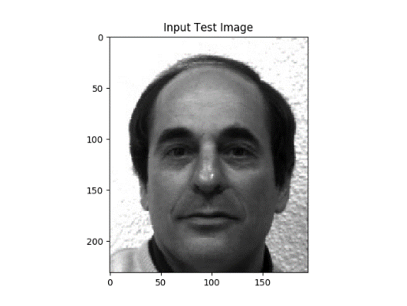 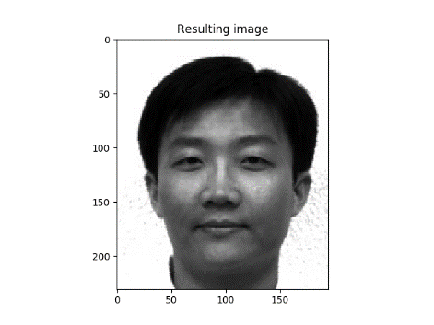

**14) For Image: subject14.happy**  
The image after subtracting the mean face (𝐼)

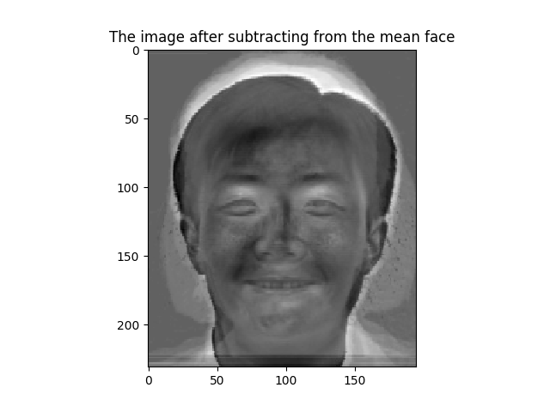

PCA coefficients

[[-28304868.25107065]

[-29345677.08782681]

[-30369106.39333002]

[ 44211266.06091312]

[-29388758.97947909]

[ 6702082.46481717]

[ 22706706.22025731]

[-52080530.81764869]]

The reconstructed face image (𝐼𝑅)

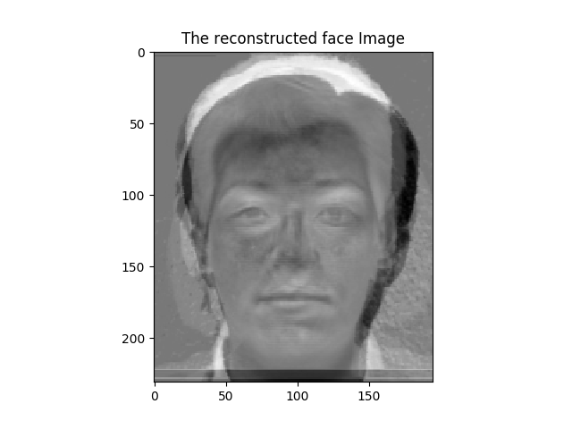

**Distance D0** is 1.32759773169e+12

**Distance D** of Test Image to Train Image is 31762428.2996

**Classification:** identify of face which is similar to subject14.normal.jpg

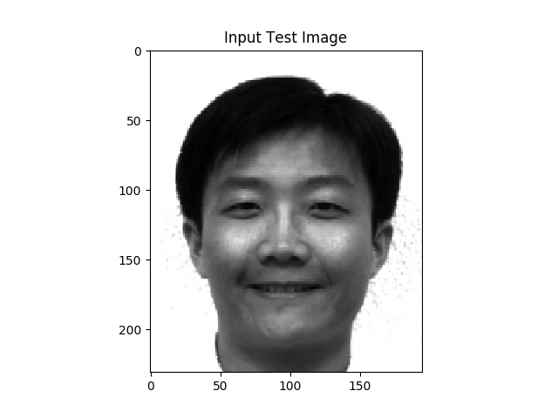 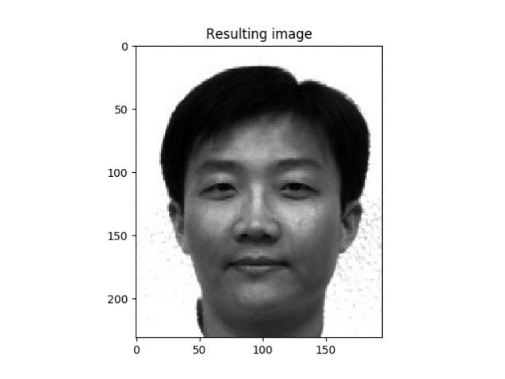

**15) For Image: subject14.normal**  
The image after subtracting the mean face (𝐼)

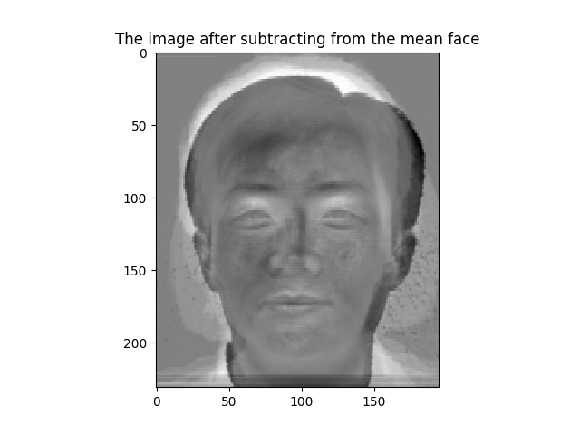

PCA coefficients

[[-23885338.95117827]

[-38020356.99247383]

[-36044721.80967677]

[ 55601146.0481776 ]

[-27169146.82748754]

[ -3647980.96953668]

[ 10181043.11415983]

[-74061996.57593761]]

The reconstructed face image (𝐼𝑅)

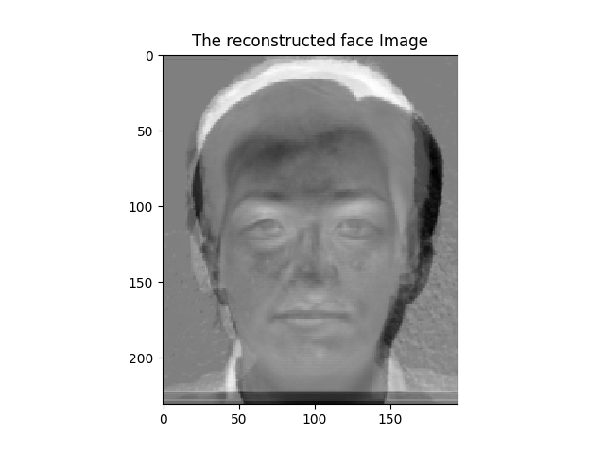

**Distance D0** is 1.64704333779e+12

**Distance D** of Test Image to Train Image is 0.0

**Classification:** identify of face which is similar to subject14.normal.jpg

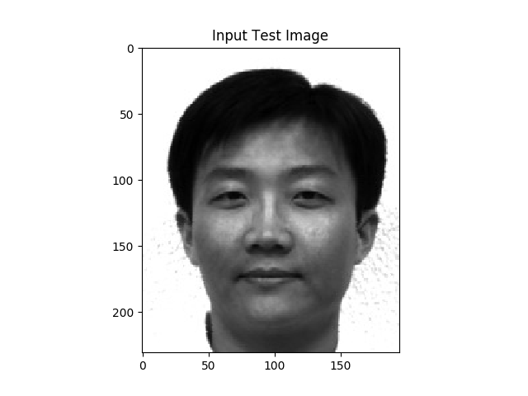 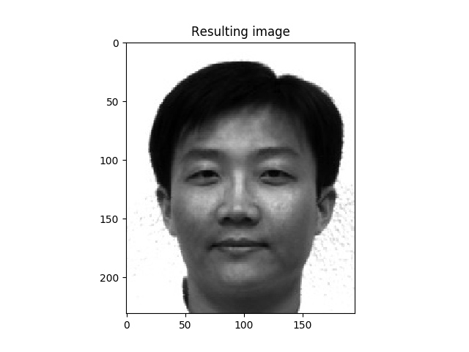

**16) For Image: subject14.sad**  
The image after subtracting the mean face (𝐼)

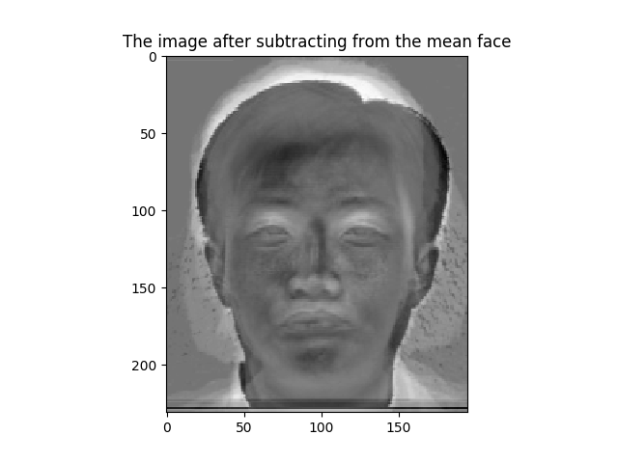

PCA coefficients

[[-13349753.5778023 ]

[-34508563.909333 ]

[-27213011.67619629]

[ 44863129.61847532]

[-20623594.37715862]

[-11242382.63339401]

[ 21272885.23194516]

[-54758778.2982702 ]]

The reconstructed face image (𝐼𝑅)

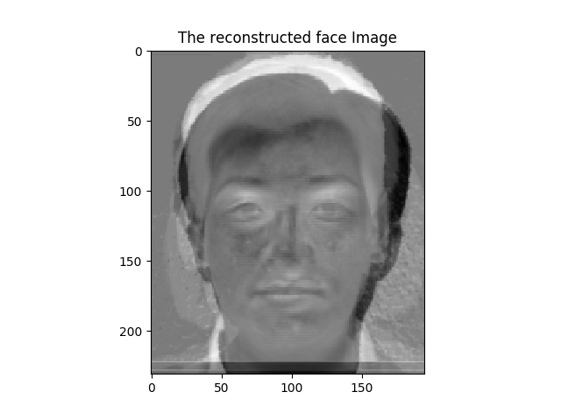

**Distance D0** is 1.21669154957e+12

**Distance D** of Test Image to Train Image is 30212542.7844

**Classification:** identify of face which is similar to subject14.normal.jpg

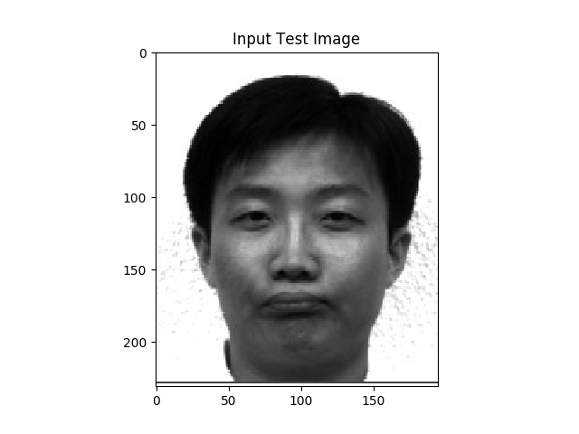 

**17) For Image: subject15.normal**  
The image after subtracting the mean face (𝐼)

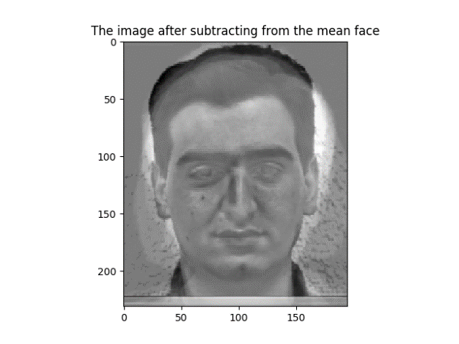

PCA coefficients

[[ -1.37470136e+07]

[ -1.13351946e+07]

[ 8.24571597e+07]

[ -5.74117559e+06]

[ 8.74542667e+07]

[ 1.14077271e+07]

[ 2.81793810e+07]

[ 1.23105910e+08]]

The reconstructed face image (𝐼𝑅)

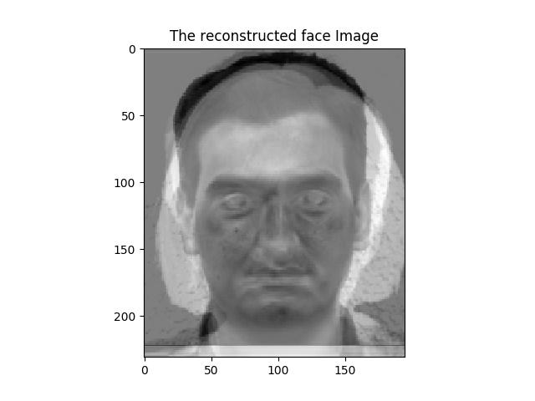

**Distance D0** is 3.24570215127e+12

**Distance D** of Test Image to Train Image is 0.0

**Classification:** identify of face which is similar to subject15.normal.jpg

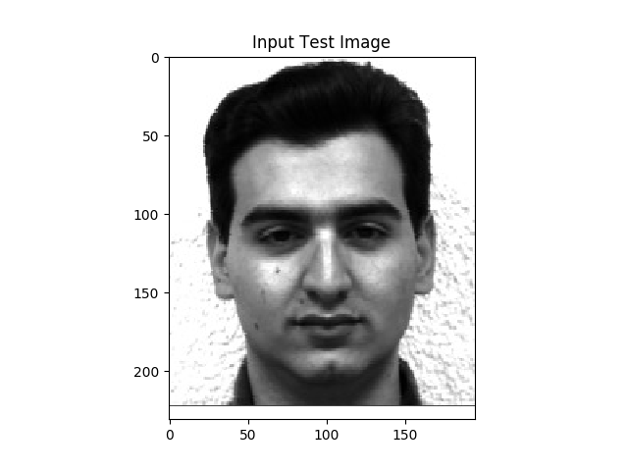 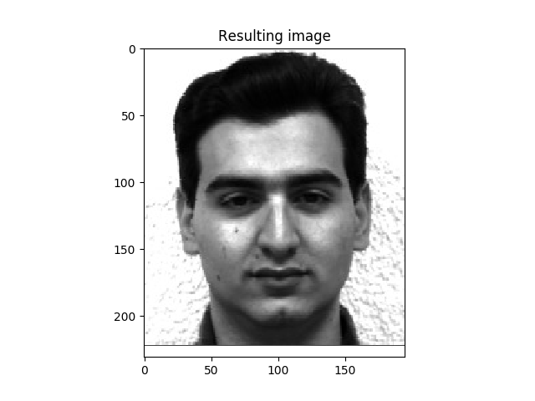

**18) For Image: apple1_gray.jpg**  
The image after subtracting the mean face (𝐼)

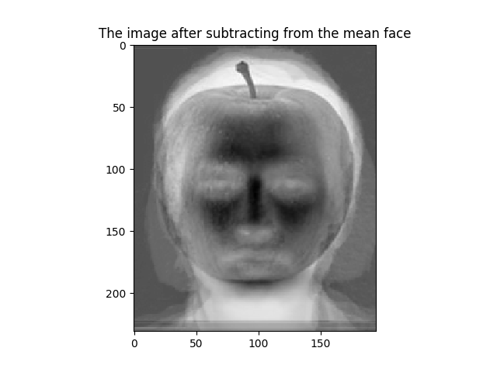

PCA coefficients

[[-42627177.01786121]

[ 29603174.38876884]

[-26535253.77380313]

[ 4710795.49591369]

[-12860160.66792136]

[ 40755115.54007928]

[ 19468225.85534585]

[ -8729543.94871198]]

The reconstructed face image (𝐼𝑅)

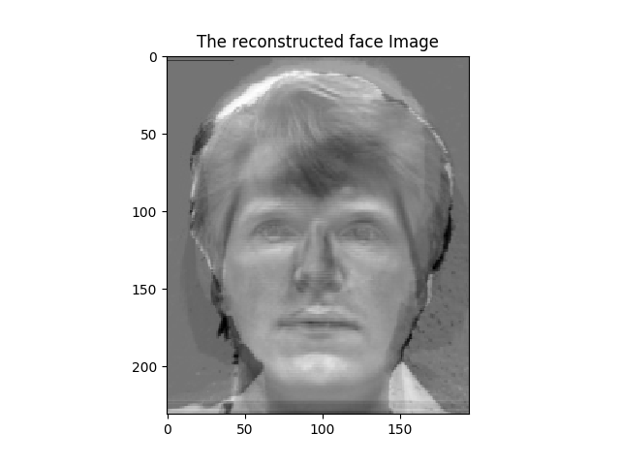

**Distance D0** is 917761191498.0

**Distance D** of Test Image to Train Image is 100111547.783

**Classification:** unknown face